Making a Data Driven Case for Quality Matters
Michelle Vonie | University of Arizona | vonie@arizona.edu
Nicole Schmidt | University of Arizona | nicoleschmidt@arizona.edu

Our QM Implementation and Program Development Journey
Stage 1: Developing an Annotated Bibliography
This project started in 2020 as part of a larger research study with the research question, “How does the QM Rubric support student success?” Since then, our QA team has continued to update and maintain it, extending our searches to include all QM-related research. Currently, it sits at 70+ articles, separated by theme and tagged with keywords.
With this wealth of research readily at hand, we began using it in a variety of initiatives. It serves to inform our own original QM-focused research, our conversations with faculty and course developers, new professional development offerings, instructor and reviewer resources, and our funding advocacy efforts.
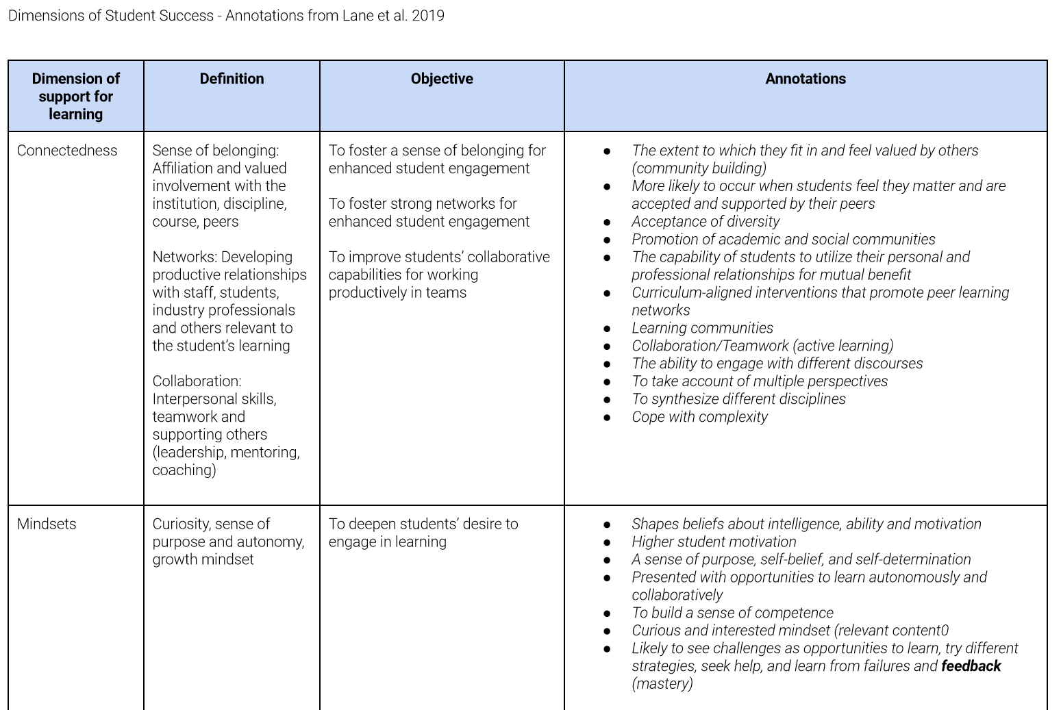
Stage 2: Mapping QM Standards to Student Success Principles
As part of the aforementioned multi-institutional research project, one of the gaps that were identified was the lack of literature directly connecting dimensions of student success to each specific review standard. In 2021-2022, we used the literature we had collected to map dimensions of student success onto the QM Rubric. For this research project, we used the five dimensions of student success from Lane et al. (2019):
- Connectedness
- Mindsets
- Self-management
- Academic capabilities
- Professional identity
The primary findings were that self-managment was the most supported dimension, with connectedness and academic abilities also strongly supported, and that the rubric did not strongly address mindsets or professional identity.
Stage 3: Developing Trainings and Resources for Instructors and Reviewers
We are currently in Stage 3, working on developing and refining trainings and resources for instructors and reviewers. We have divided our efforts into supporting reviewers and supporting instructors, the latter of which we had particular need for. The primary impetus for this effort was the amount of literature that we found, supporting the effectiveness of faculty training. To better support faculty in their understanding and application of QM Standards, we created a course revision clinic, in which we guided and supported a small group of instructors with no previous QM experience through QM-based revisions. We are also working on creating an Instructor Resources Site in our LMS with self-review checklists for each standard, just-in-time trainings, templates, and examples from QM-certified courses. For reviewers, we have created and are continuing to grow and develop a Reviewer Resources site, which includes a library of annotated examples from courses that have met QM standards, FAQs, guidelines for the review process, and a database of creative ways courses have met standards. We are also working on creating continuing development events, such as our current Quality Counts webinars, which provide an in-depth look/review of each standard.
Stage 4: Develop a QM Professional Learning Community Across Campus
Our next stage is to develop a thriving QM professional learning community within our institution. We already have regular Chair Chats with all of our active chairs to review new resources, QM updates, and share any issues that arose in their recent reviews. As part of our continuing development initiative, we are also launching harmonization meetings to ensure that there is generally consistency across all of our internal reviews. To bring new faculty into the QM community, we have developed a Quality Matters Faculty Fellowship Institute, with the goal that these faculty will serve as QM ambassadors and leaders within their colleges. Our future plans include facilitating a Faculty Learning Community and holding regular reviewer appreciation events.

