QM Regional 2019 | “Embedding Quality: Which QM SRSs Can We Meet by Following LMS Templates?”

Presenters: Kayhan Sanyal | Justin Saunders | Matthew Vaughan | Columbia University SPS

AGENDA | DESCRIPTION | TIME (minutes)
ICE BREAKER  “2 Truths and a lie” | - Divide groups based on their roles in the organization.  - Write 2 truths and a lie about yourself in your group.  - Share with the rest of your group. | 5
GROUP ACTIVITY  “Your Personalized Template” | - Choose from one of the following pages: Getting Started, Discussion, Assignment, Support, or Resources Page.  Prompt: “Which SRS can be visually integrated into your page?”  - Work in your team to design a ‘wireframe’ of the page.  - Use the resources provided to plan the structure and content of the page.  - Include the identified SRS.  Reflection: “Were there certain SRS that were not included in your page even though they might have been appropriate? What choices impacted your decisions around the inclusion of SRS in your page? | 20
PRESENTATION  “Building and Communicating Alignment through Templates” | - Quality through Templates  - SPS Syllabus Template  - SRS and Fitness Criterion  - Best Practices | 15
CLOSING  “Whole group discussion” | Prompt: “What are some strategies that you can use to acquire SRS specific information from your faculty?” | 10

QM Regional 2019 | Interactive Activity

Group Options:
- Resources
- Discussion Pages
- Getting Started
- Learner Support
What My Should Our Wireframe Look Like?
- It should represent your understanding of the “dream” page for its purposes.
- It should clearly describe a content structure only (don’t worry about “Lorem Ipsum…”).
- It should have key components sketched as they would appear on an actual site.
- It should describe the purpose of each element on the page.
- It should have annotations for which SRSs would work at various points in the page.
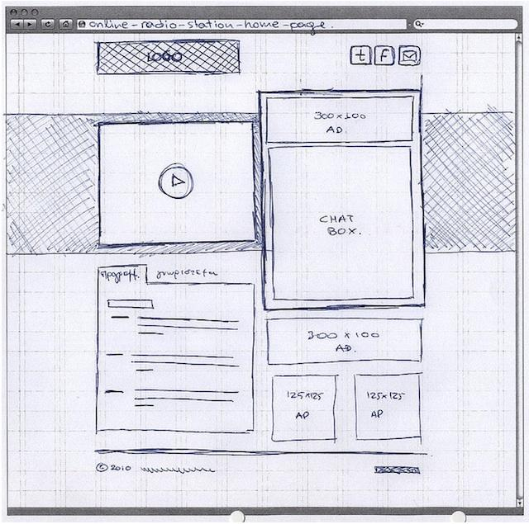

Using LMS Templates to Meet QM Specific Review Standards

Tensions and Questions re: Best Practices for Using Templates to Meet Select Specific Review Standards (SRSs)

The following are general maxims that seem intuitive related to the nature of templates. But they are at odds with one another. As a group exercise, please discuss and decide which item from the dichotomies below makes sense to you.

Tension #1: Location, Location, Location.

Which of these two options makes the most sense to you? Why?
A. Do not place too much emphasis on the Syllabus page(s). |  | B. Limit the number of locations in which students would access information.

Tension #2: Stock Language.

Which one works in the real world?
C. Use prompts and links whenever possible, rather than writing content out. |  | D. Pre-populate as much content as possible.

“Fitness Criteria” for SRSs to be ‘Met’ via a Template

- The SRS is looking for something there or not.
  - For example, many of the SRSs on General Standard 7 (re: Support) are Yes/No.
- The SRS can be met within one location.
  - For example, the SRSs within General Standards 4 (Instructional Materials) and 5 (Activities) are a poor fit.
  - The SRSs within General Standard 6 (Tools) might be a good fit.
- The SRS is easy to cluster with other “like” items. “Findability” is one of the most important considerations to students!
  - For example, many of the items to meet SRSs within General Standard 2 (Objectives) could be placed together.
- The SRS represents items that don’t have to do with content.
  - This would mean that many of the Alignment Standards would likely be a poor fit. Or would they?

Guidelines and Design Principles for LMS Templates

By Justin Saunders

DESIGN PRINCIPLES | ANNOTATIONS
Layout | All of the elements on the page are assembled in a logical way that makes sense to the student.  The page’s hierarchy is clear from the position of elements and the correct use of headings.  The page facilitates ease of use—text is easy to read, and elements are easy to find.  The structure of the page is aesthetically pleasing, and there is appropriate spacing between elements.  The page is consistent with the rest of the student experience. If a recurring element appears in one place in other pages it should appear in the same place on this page.
Content | The suggested minimum and maximum word-count range is clearly communicated for text elements. Model content blocks with suggested word counts and placeholder text.  Example:  (Suggested 100 word count) Lorem ipsum dolor sit amet, consectetur adipiscing elit. Sed non luctus mauris. Integer molestie pellentesque augue, a tempor dui viverra eget. Nunc viverra ullamcorper libero. Etiam vel auctor ligula. Sed iaculis lacus eget purus accumsan, ut imperdiet nibh venenatis. Praesent sit amet sodales mauris. Curabitur vel nisi eu tellus pretium tincidunt id quis risus. Suspendisse ac faucibus massa. Suspendisse lorem dui, pellentesque at libero ut, ullamcorper vestibulum risus. Vestibulum ante ipsum primis in faucibus orci luctus et ultrices posuere cubilia Curae; Mauris vitae mollis nisi, nec ultricies dolor. Phasellus et cursus ex, a sagittis justo. Vestibulum ante ipsum primis in.
Semantically sound HTML | Most HTML elements have specific semantic purposes. For instance, a <p> tag specifically defines the beginning of a paragraph, and an <h1> tag specifically defines the beginning of a top-level heading. Each element matches its semantic purpose according to W3C.  One example of misusing an element is repurposing tables for the ability to control cell size. Tables should only be used for communicating tabular data, not to create layout.
Space constraints | If you are working in a learning management system (LMS), then you likely have a constrained viewport. Take the limited space into consideration when building your template.  Remember, also that users are used to scrolling content from top to bottom, not left to right.
Images | Be deliberate about your use of images. Determine whether your images are decorative or content.  If your image is content, include an appropriate alternate-text tag. If your image is decorative, use a null alt tag (alt="").  Replace images of text with text to assist with accessibility.
Mobile responsiveness | Consider how students will engage with your template using a mobile device.  Use mobile-first responsive design.  New devices with different screen sizes come out every year. If you do not have the resources to maintain templates, keep them as unstyled as possible.  Text is inherently responsive, images can be made responsive with relative ease, and tables can be difficult to control for responsiveness.
Color | Be intentional, consistent, and specific with your use of color. Define why you are using specific colors and what those colors signal to students and to content developers.  Make sure your colors meet WCAG 2.1 standards for contrast ratio (AAA standard for normal-sized text is 7:1).
Typography | As with color, be intentional, consistent, and specific with your choice of typographical variety. Define where and when text is underlined, bold, or italicized and when the size of text should change.  Headings should be used to give a page its structure. Content developers should stay away from simply changing text size and color to create headings, and should use proper HTML elements (<h1>, <h2>, <h3>, <h4>, <h5>, <h6>).  Heading levels should not be selected for their style, but for their semantic hierarchy.

