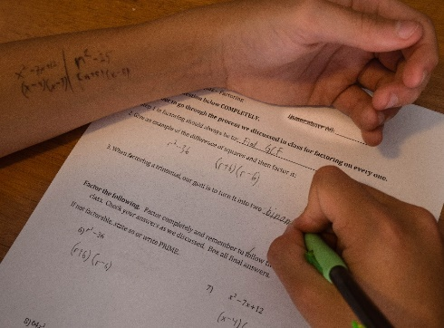
Image courtesy of vozach1234 on Flickr

Cheating Allowed!

As we are gathering and getting settled in, please take a few moments to answer these questions. If you do not know an answer, introduce yourself to your neighbors and ask them for the answers. Move around the room if necessary to answer as many of the questions as possible! Have fun!!

- What is the topic of General Standard 4 of the QM rubric?

- What is the topic of General Standard 5 of the QM rubric?

- When and where was the term “Open Educational Resources” coined?

- What is your definition of Open Educational Resources?

- What are the 5 ‘R’s of open licensed content?

- Name one organization that offers open licensing.

