Research-Driven, Student-Informed: Shaping Quality Assurance in Online Education
Michelle Vonie | University of Arizona | vonie@arizona.edu
Samantha Maxwell | University of Arizona | samkm@arizona.edu

The Path to a Student Advisory Board
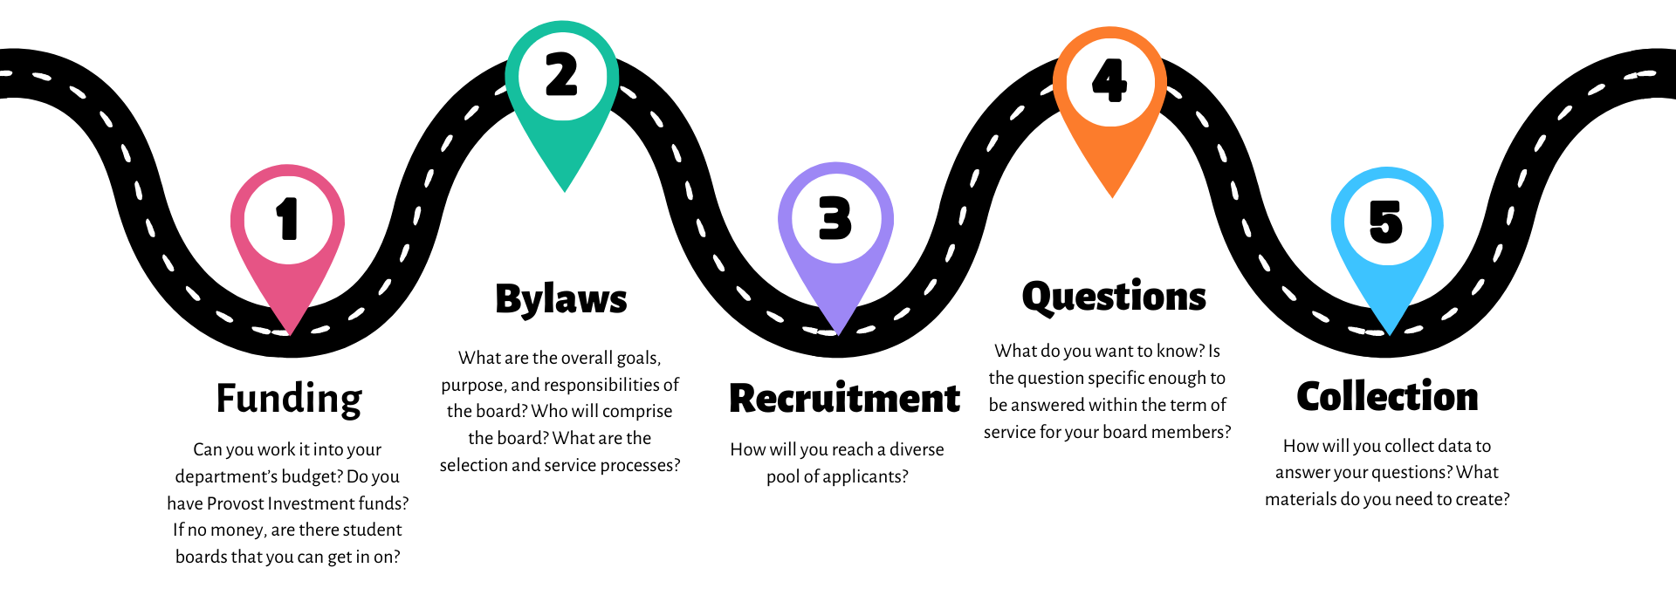

Our Process in Four Steps

Introduce Tool to the Student Advisory Board for Instructional Technology
In the Spring meetings, we introduced educational technologies to pilot within UArizona. Over the course of the semester, students would explore these tools and watch faculty videos on how the tool was implemented in courses.

Requests for Feedback
We designed questionnaires with Likert scales and open-answer feedback. These questionnaires were designed to have students evaluate the tool based on QM standards, such as the tool's level of accessibility.

Analyze the Data
To utilize the student feedback, we first performed some basic quantitative analysis on the closed questions. Then, we separated the open-ended questions and open-coded for themes.

Apply the Findings
We used these themes to inform our recommendations of how instructors integrate technology into their course, build out a tech inventory, and inform instructor training.

Taking a Research-Driven Approach
- Identify the gaps in your knowledge/data
- Create your research questions
  - e.g., What do students value the most out of the QM standards?
- Determine your data collection methodology
  - Based on your research questions (and potentially, how you plan to use this data) is it more appropriate to collect quantitative data, qualitative data, or a mix of both?
- Design your materials
  - Remember that you will want to analyze and apply this data later on, so ensure that you are able to continue to work with your data
- Analyze your data and apply your findings
  - Determining how you will analyze your data will allow you to see what resources are needed and ensure continued use and interaction with your findings
  - Ensure that your collection and analysis of your data aligns with its intended use

