How to Make Accessible Word Documents (Make this Heading 1)
Text is the most often used format for presenting or sharing information. Luckily, it’s also the most accessible format, if it’s formatted correctly. You will use this document to practice the five steps involved in making Word documents accessible. NOTE: This document is intentionally inaccessible, so it may be difficult to follow until you have adjusted formatting.

Objectives (Make this Heading 2)
- Use Headings.
- Add alt-text to graphics.
- Use descriptive hyperlinks.
- Use built-in styling tools to format text accessibly.
- Label data tables.

The 5 Easy Steps to an Accessible Syllabus (Make this Heading 2)

Step 1: Use Headings (Make this Heading 3)
Sighted viewers can scan a page and use visual cues like larger or bolded text to find the section of a document that they want to read. For someone using a screen reader, these visual markups are useless - leaving them to navigate word by word from the start of the document or webpage until they find the section they want.
Using headings and styles will allow a screen reader to navigate from section to section, making for a more convenient experience for the user.

How to apply headings:
- Highlight the document title, select ‘Heading 1'.
- Highlight the section titles, select ‘Heading 2’.
- Highlight the subsection titles, select ‘Heading 3’.
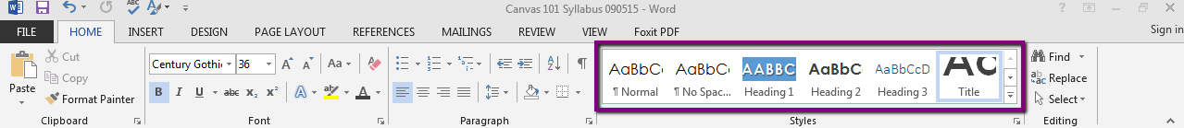
Use the section titles in this document to practice adding headers (HINT: To help get you started, some of the heading levels are marked in light gray.)

Step 2: Add Alternative Text to Graphics (Make this Heading 3)
Alternative text, also called alt-text, is text associated with an image or other graphic that someone unable to see the image understands what the image conveys. Alt-text should be under 100 characters and provide a short and sweet description of the image given the context in which it is presented.

How to add alt-text to images:
- Right click on the image.
- Select ‘Format Picture’.
- Click on ‘Alt-text’ and type a description of the image.
- If the image is purely decorative and you want a screen reader to skip over it, be sure to check to make sure the file name is not listed as default alt-text. Press the spacebar and then enter to indicate the image is decorative.
Note: Enter your alt-text into the description field, not the title.
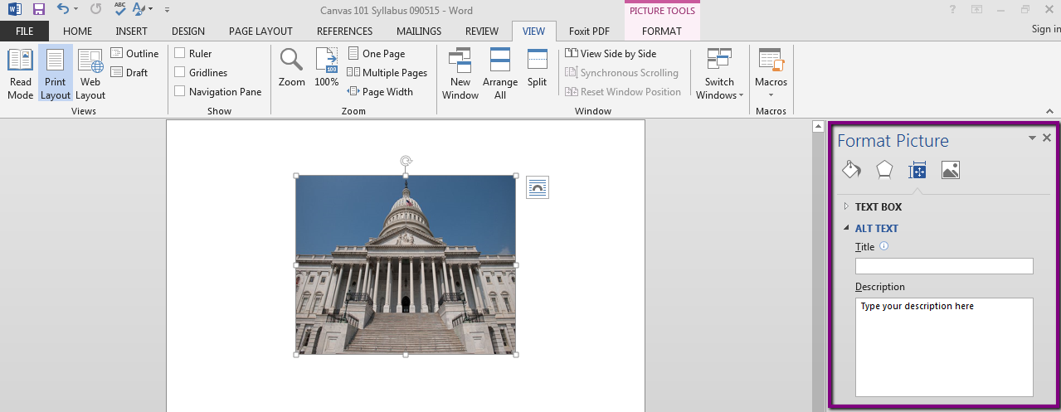

Use the image below to practice adding alt-text:
Effective Online Teaching: Foundations and Strategies for Student Success by Tina Stavredes
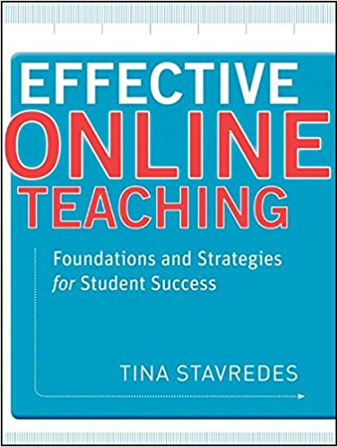

Step 3: Use Descriptive Hyperlinks (Make this Heading 3)
When you want to include a URL in your document, you want to use descriptive hyperlinks. That involves embedding the URL into text. For someone using a screen reader this is helpful by telling them where the link will take them and avoid having to listen to a screen reader read the full URL. (You can listen to what it’s like by playing this short audio of JAWS reading a hyperlink.)

How to add a descriptive hyperlink:
- Ask yourself what students need to learn from this image?
- Write a sentence containing contextualized descriptive text.
- Select the text phrase to link.
- Click on the ‘Insert’ menu.
- Click on ‘Hyperlinks’ or ‘Links’.
- Copy the URL and paste it into the ‘Address bar’.
- Click on ‘OK’ to save.
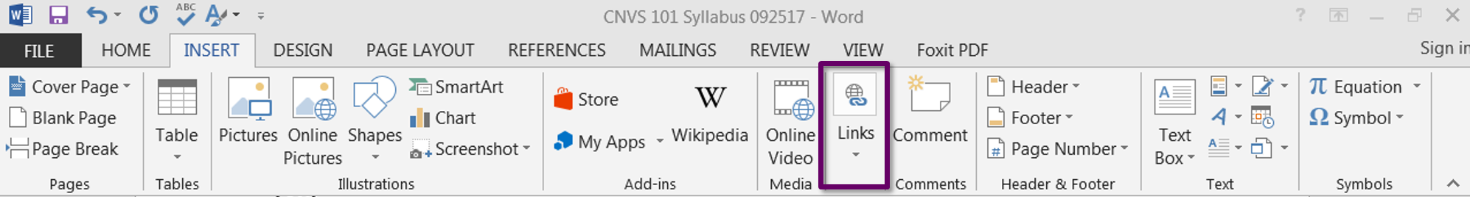
For practice, convert the URL below to a descriptive hyperlink.
- For more information, visit the Canvas Guides at https://community.canvaslms.com/community/answers/guides

Step 4: Use the Built-In Styling/Formatting Tools (Make this Heading 3)

Lists (What heading level should this be???)
Use bulleted or numbered lists by using Word's formatting tools (not by typing the numbers or dashes yourself). Using the list formatting tool allows a screen reader to determine the length of the list and the reader can understand how the content is organized and how many items are on the list. When you click on what appears to be a list, the list icon will be selected. If it’s not, then the “list” has not been formatted as a list.

How to reformat a list:
Step 1: Delete whatever is being used to define the item (a dash, a number, etc.)
Step 2: Highlight the list text.
Step 3: Click the bulleted or number list button (you can specify the type of list by clicking the dropdown menu option)
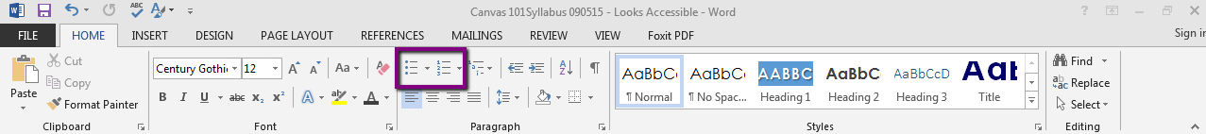
Use the incorrectly formatted list above to practice making a true bulleted or numbered list.

Columns of Text
Many people use the tab key to create columns of text. Since a screen reader is going to read left to right, using tab to create columns will result in the screen reader reading by line, not column. For instance, the columns below would be read as ‘Office Hours, Phone, Classroom, Monday 1:00 – 2:00 PM, Office: (425) XXX-XXXX’ and so on.

Office Hours Phone Classroom
Monday 1:00 – 2:00 PM Office: (425) XXX-XXXX B104
Tuesday 1:00 – 2:00 PM Cell: (425) XXX-XXXX

How to reformat a Column:
- Retype the text in a running list.
- Click on the ‘Page Layout’ menu.
- Select the text to put into columns.
- Click on ‘Columns” and select the number of columns desired from the drop down menu.
- To add column breaks, place the insertion point where you want to add the break.
- Click the ‘Page Layout’ tab.
- Click the ‘Breaks’ command in the ‘Page Setup’ group.
- Select Column from the list of break types on the drop down menu.
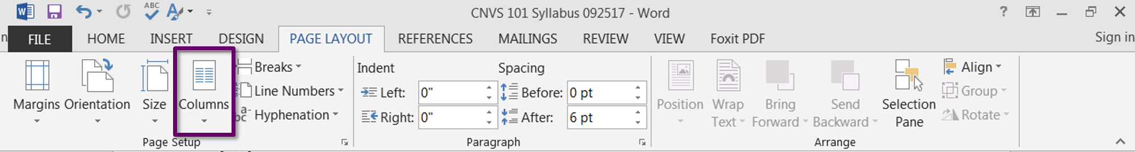
Use the inaccessible columns above to practice. (HINT: You will need to start by removing the tabbed spacing and creating a new running list that can be made into a column but sometimes retyping from scratch is faster.)

Spacing
Use page breaks, line spacing, and the increase/decrease indent keys to create extra
Space. Avoid tabbing over, hitting the space bar multiple times, and blank lines of text.

How to add line spacing:
- Select the text to space.
- Click on the ‘Home’ menu.
- Click the drop down menu in the Paragraph options
- Choose your spacing options. You can add indents, line spacing and tabs from here.
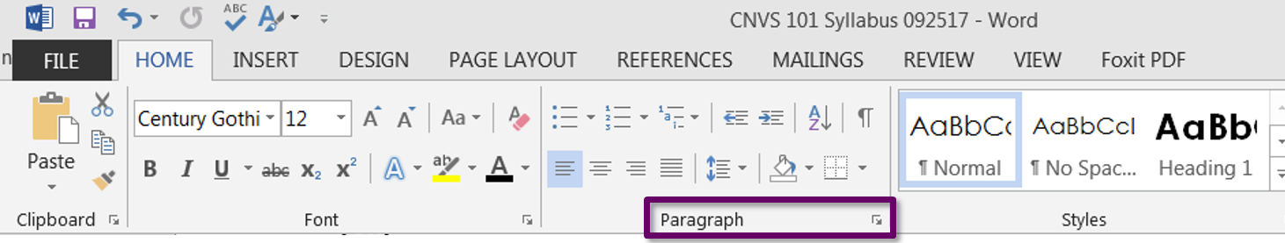
Use the text above to practice spacing & aligning text. (HINT: Delete the extra spaces at the beginning and middle of the sentence in the first paragraph of this section and then reformat it using one of the many styling tools.)

Step 5: Label Tables
Tables should only be used to convey data, never to control the layout of a document. Screen readers will read a table from left to right starting at the top. The relationship between the cells is not defined by a screen reader if it is not formatted correctly, meaning that the category that a piece of data falls into will not be identified by the screen reader.

How to create an accessible table:
- Highlight the row that includes the category titles.
- Right click the row and select ‘Table Properties’.
- Click the ‘Row’ tab, and check the checkbox that says “Repeat as header row at the top of each page” (unselect "Allow row to break across pages.").
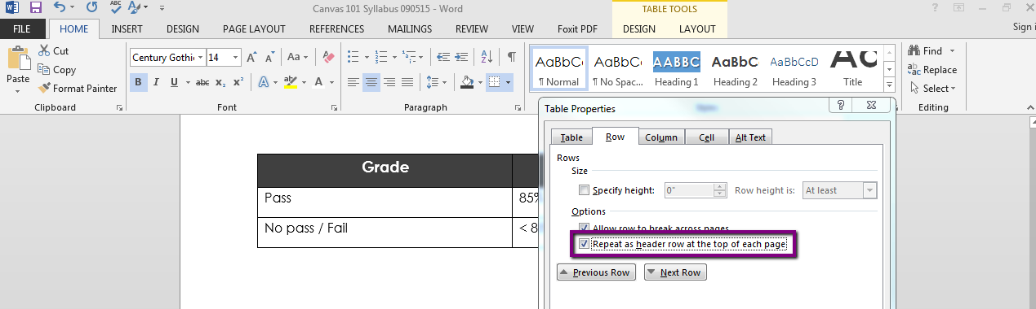
- Click the ‘Alt Text’ Tab to add further description.
- Add a caption for your table - select the table and right click to access the menu.

Use the unformatted table below to practice creating an accessible table.
Letter Grade | Points | Percentage
A | 90-100 | 90 – 100%
B | 80-89 | 80 - 89%
C | 70-79 | 70 – 79%
D | 60-69 | 60 – 69%
F | Less than 60 | Below 60%

The Accessibility Checker!!
We aren’t the only ones that want you to make your documents accessible, so does Microsoft – that’s why they created the accessibility checker. You can go to file, then select “check for Issues” in order to get to the accessibility checker. Not only will it point out errors, but it will tell you how to fix them.
But, a few things to be aware of:
- the checker will not point out that you’re not using headers
- the checker cannot determine if your alt-text is appropriate
- the checker will not tell you anything in terms of font type, size, or color contrast
- the checker cannot determine if your headings are in the right order

How to run the accessibility checker:
- Click on the File menu tab.
- Click on Check for Issues.
- Click on Check Accessibility.
- Read the Inspection Results.
- Read the Why Fix information.
- Click on any error to be taken to is within your document.
- Make your corrections.
- Rerun the checker as needed.

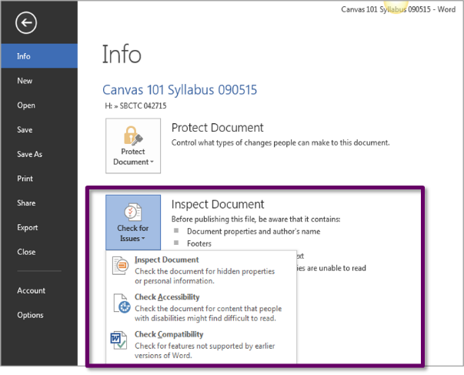

Practice running the accessibility checker on this document to check your work. Did you miss anything?

Additional Tips (EX: Make this Heading 2)

Bonus Tip 1: Use Color Responsibly (EX: Make this Heading 3)
Be careful with how you use color. Never use color alone to convey meaning (ex: “Items to edit are in red.”) – if someone is colorblind they will miss those cues. For someone using a screen reader you should always have a text alternative available.

You should also have sufficient color contrast between the background and text colors. Some color combinations, such as red and green, are difficult for those with color blindness to distinguish.

Bonus Tip 2: Use Text Responsibly
- Use simple language - no jargon!
- Avoid using abbreviations.
- Avoid using ALL CAPS.
- Punctuate sentences.
- Spell out acronyms.

Bonus Tip 3: Use Fonts Responsibly (EX: Make this Heading 3)
In terms of font accessibility, there are a number of principles to keep in mind:
- Use real text rather than text within graphics.
- Select basic, simple, easily-readable fonts.
- Use a limited number of fonts.
- Avoid small font sizes.
- Limit the use of font variations such as bold, italics, and ALL CAPITAL LETTERS.
- Don't rely only on the appearance of the font (color, shape, font variation, placement, size, etc.) to convey meaning.
- Avoid blinking or moving text.

Content from http://webaim.org/techniques/fonts/

Bonus Tip 4: Use Images Responsibly
- Images should add to, not detract from, the learning.
- Always locate images near the content providing the context because proximity implies relationship.
- Always set the image wrapping style to “In Line with Text” because text that wraps around an image can be confusing.
- Use open source images and attribute the author.

Bonus Tip 5: Converting to PDF (EX: Make this Heading 3)

The easiest way to ensure you’ve created an accessible doc, is to create it in Word using the steps above and save it as a PDF from Word.

How to create an accessible table:
- Click on File, select the PDF file type, and click on options.

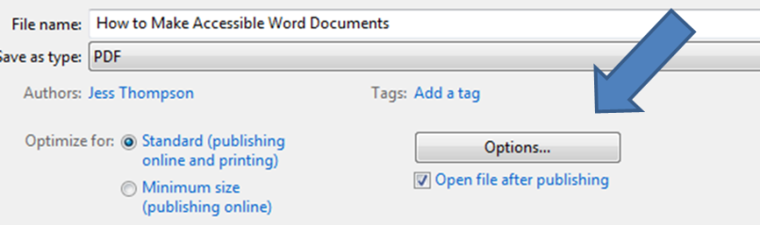

- Make sure “document structure tags for accessibility” is checked.
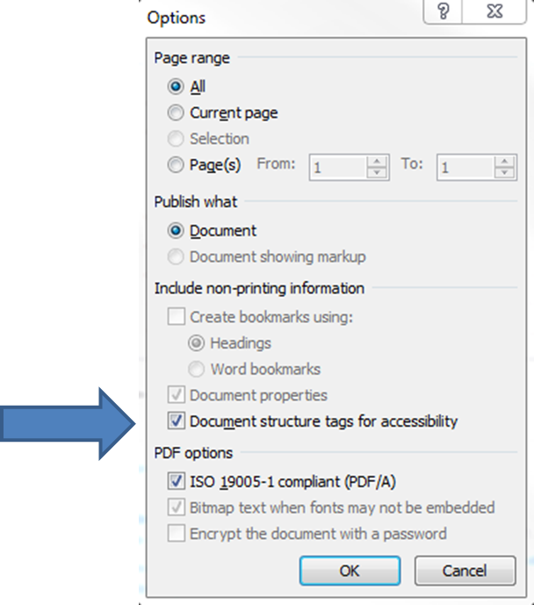

A scanned page from a book is inaccessible. It cannot be read by a screen reader or searched by a student. Scanned images can be converted to text using OCR. PDFs should never be scanned images.

Now for practice by saving this document as a PDF.

