QM & Faculty: Planning for Your Internal Partnership
What will you do?
Step 1: (Scoot) Where will you begin the partnership?

Step 2: (Balance) How will you build on the partnership?

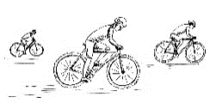
Step 3: (Pedal) What are some things you will do to strengthen the partnership?

