- Get a Passport? Several digital badge grantors have dropped the smaller, less popular services in favor of other larger, more portable services. One popular service is Mozilla’s Backpack system. Example: Here’s a college library that has dropped Passport in favor of another option and their LibGuide for using it. (See full document at http://libguides.richlandcollege.edu/libraryclasses)
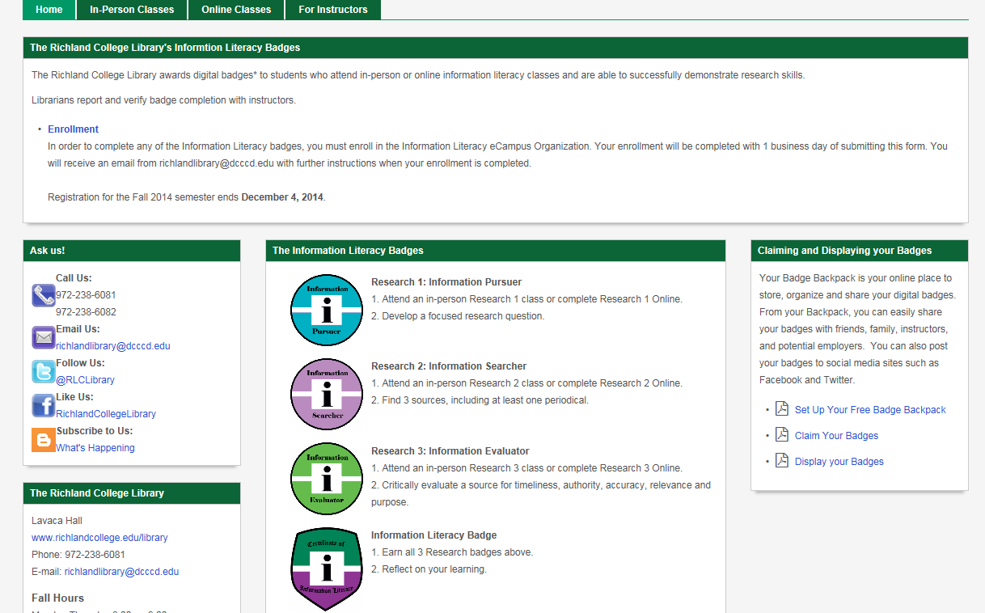
Pdf docs to instruct users to start their own Mozilla Backpack
Four different badges available, from Richland College library,
with the final badge being proof of earning all three prior.
(Notice the unique shape for the mastery-level badge.)

- Why OpenBadges? It is not proprietary and is already known/trusted by many users
(i.e. Firefox).
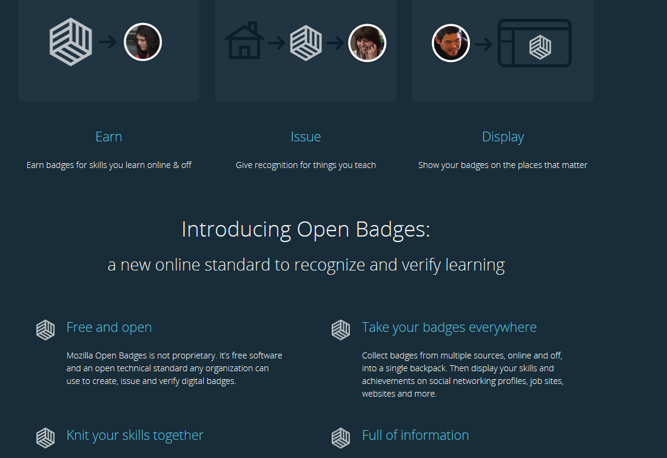
Highly portable, and Self-Managed once badges are earned/accepted.
Free and Open.
ANY organization may use it.
- Once a Person Earns Badges: Backpack users are pretty much set “forever” like having a Yahoo! or Google account. It is portable to all jobs, schools and so forth. Once a badge is given, the onus is on the recipient, much like certificates have always been.
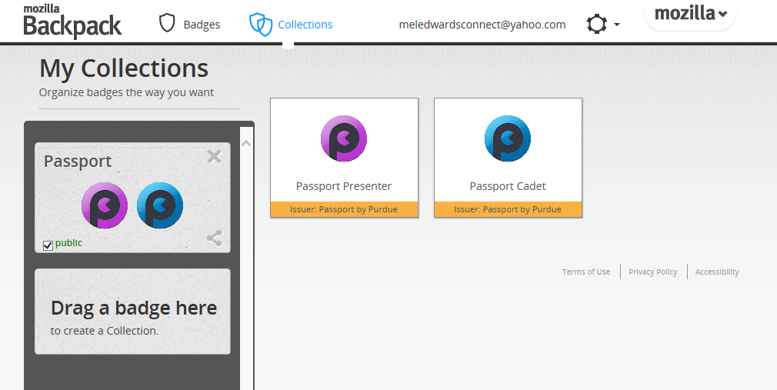
I may have earned many badges over a long period,
but I can put them into Collections (note center of header). Collections allow grouping. For example, Work badges could be one group, and College badges could be another and so on.
Then I can make them public by checking the box.
This could be put on professional sites like LinkedIn and in my e-portfolio or online resume.

- Anyone can give badges and set up criterion. That means, if we have a SkillsUSA club, Kevin Ruby (as Advisor) could make a badge for members, one for officers and so forth. Meanwhile, as an institution, we can have badges for a number of departments and gateways to success, making our high-touch system visible to students and gamifying the process of becoming a strong student by offering a variety of ways for winning badges.

The next document MSUN In-House Digital Badges is a school-wide example of how badges could be used here at MSUN followed by a final document for ideas of how badges may be used by an Instructor-Awarded Digital Badges within a course.

